**Reading Comprehension- the Keyword methodology**

Read the following paragraphs and look for the words that define the key idea of the passage. Choose the option that best captures the essence of the text.

1. You seemed to take no notice of your school-fellows, or rather to set yourself against them because they were strangers to you. They knew as little of you as you did of them; this would have been the reason for their keeping aloof from you as well, which you would have felt as a hardship. Learn never to conceive prejudice against others because you know nothing of them. It is bad reasoning and makes enemies of half the world. Do not think ill of them till they behave ill to you and then strive to avoid the faults you see in them. This will disarm their hostility sooner than pique or resentment or complaint.

**Now look for keywords:**

| **Keywords: Your answer** | **Keywords: Correct Answer** |
| --- | --- |

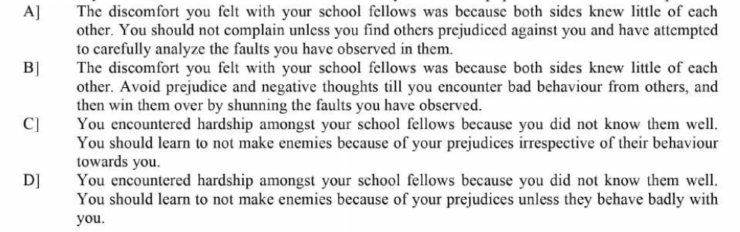

2.Shams-ud-din Muhammad Hafiz (c. 1320-1389) is one of the most beloved poets of the Persians, and is considered by many – from different cultures – to be one of the seven literary wonders of the world. Ralph Waldo Emerson and Johann Wolfgang von Goethe both agreed. As Emerson said of Hafiz: "He fears nothing. He sees too far, he sees throughout; such is the only man I wish to see or be." And Emerson gave Hafiz that grand and famous compliment, "Hafiz is a poet for poets." Hafiz poems were also admired by such diverse notables as Nietzsche and Arthur Conan Doyle, whose wonderful character Sherlock Holmes quotes Hafiz. Garcia Lorca praised the Sufi poet. Johannes Brahms was so touched by his verse he used several in his compositions. And even Queen Victoria was said to have consulted Hafiz in times of need.

| **Keywords: Your answer** | **Keywords: Correct Answer** |
| --- | --- |

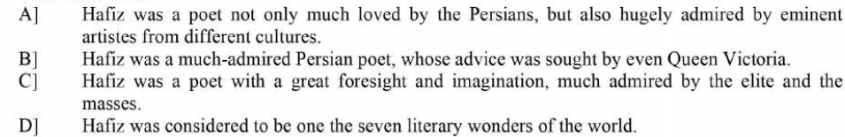

3. Being good at sports requires talent but only when talent and ego are in perfect symmetry, a player can make the leap from good to great.Forde uses a formula - (ego + coachability) x learning culture - with high-performing teams and individuals to help them maximise their talent. "The equation shows that ego is the foundation of greatness but only if it is still open to being coached and criticised and there's a structure in place to help them grow," he said. It is an equation that explains the success and longevity of some top sports stars.The ego is in place to give them the confidence to perform on the biggest stage.

| **Keywords: Your answer** | **Keywords: Correct Answer** |
| --- | --- |

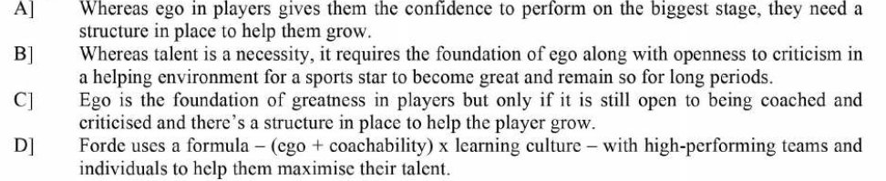

4. 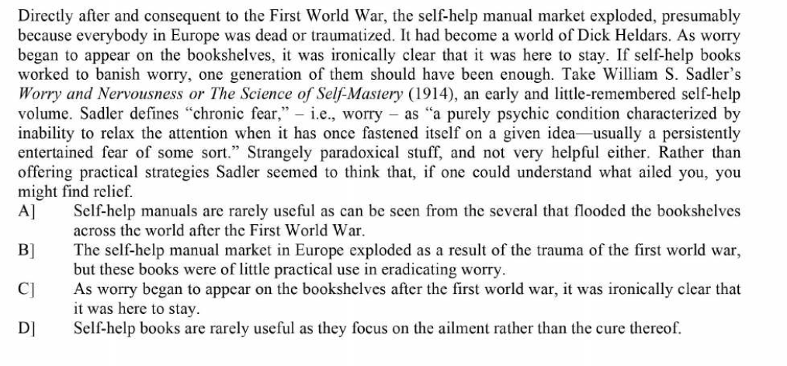

| **Keywords: Your answer** | **Keywords: Correct Answer** |
| --- | --- |

5. I was on a tech podcast discussing Google’s decision to remove links to revenge porn from its search results when victims request it. If you can’t make it disappear, you can at least make it more difficult to find. I supported Google’s decision to make life harder for the world’s creeps, but my host considered it a slippery slope. “If you’re going to say, ‘I’m going to make a search engine,’ ” he said, “you should make one that indexes what’s on the Net, regardless of content.” He was concerned that “editorial intervention always introduces bias,” choosing instead to put his faith in an algorithm that “can be completely objective. “My adversary was espousing what is called information universalism. It means that we should not stomach any limitations on speech, because of what freedom means and guarantees. Not only is this a misreading of the term freedom but as our lives increasingly interact with the Internet, this attitude, while noble in theory, is more dangerous than ever.

| **Keywords: Your answer** | **Keywords: Correct Answer** |
| --- | --- |

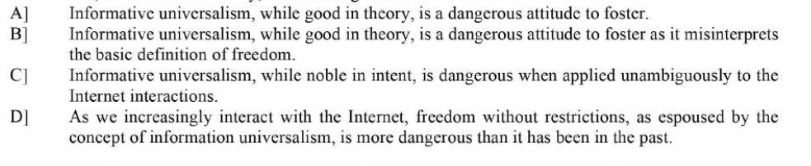

**Read the following passages/Exercises**

Passage 1

Organisations are institutions in which members compete for status and power. They compete for resource of the organisation, for example finance to expand their own departments, for career advancement and for power to control the activities of others. In pursuit of these aims, groups are formed and sectional interests emerge. As a result, policy decisions may serve the ends of political and career systems rather than those of the concern. In this way, the goals of the organisation may be displaced in favour of sectional interests and individual ambition. These preoccupations sometimes prevent the emergence of organic systems. Many of the electronic firms in the study had recently created research and development departments employing highly qualified and well paid scientists and technicians. Their high pay and expert knowledge were sometimes seen as a threat to the established order of rank, power and privilege. Many senior managers had little knowledge of technicality and possibilities of new developments and electronics. Some felt that close cooperation with the experts in an organic system would reveal their ignorance and show their experience was now redundant.

A. Frustration of Senior Managers

B. Emergence of Sectional Interest

C. Groupism in organization

D. Individual Ambition inOrganization

**Passage 2**

Ancient chronicles say that Teti, founder of Egypt’s 6th dynasty more than 4300 years ago, was assassinated. His successor lasted less than two years before Teti’s son Pepy I seized power and punished the killers, including Teti’s chief administrator and several bodyguards. Recent excavations of Teti’s cemetery at Saqqara suggest that the traitor’s punishment extended to eternity: their names and likenesses were chiselled off the walls and doors of their tombs. “This deprived the tomb owners of perpetual life in the hereafter.” says Naguib Kanawati.

Choose a suitable title for the passage

|  |  |
| --- | --- |
| | A. | Life Sentence | | --- | --- | | B. | The Egyptian Tale | | C. | The Chronicles of Teti | | D. | (After) Life Sentence in ancient Egypt | |

**Passage 3**

Why do unhappy events stay on in the mind? Why are we haunted by those episodes in our lives which left us grief-stricken, frustrated, resentful, hurt, guilty or upset, and not by those which left us happy and contented? Across the mind’s screen, unpleasant images of the past flash by more often than fulfilled, pleasant ones.

Perhaps the key lies in the word ‘fulfilled’. Fulfilment implies completion. It refers to something that is over, finished with, with no loose ends. In today’s computer jargon, that file would be said to be ‘closed’.

We need to click the mouse on the filename if we wish to open it. Otherwise, the file is safely tucked away inside some folder, somewhere: Part of the many seldom-opened files in the mental computer. However, the numerous haunting memories continue as ‘current’ files. Something in each one of them remains to be finished. It may well be an apology that was due. It could also be unwillingness on our part to accept a loss. It may well be that a part of the mind continues to deny the reality of that particular event.

Choose a suitable Central Idea for the passage:

1. Unlike memories of happy events, the memories of sad events stay with us and haunt us throughout our lives.
2. Happy events are associated with a sense of completion, whereas the unhappy ones haunt us because they are incomplete and our mind denies the reality of the event.
3. Unhappy events in our lives are the ones that linger in our minds and affect our peace and mental stability.
4. Our minds, by trying to banish the unhappy events , end up in remembering them more often than happy events.

**Passage 4**

Often we hear of the generation gap — that huge expanse between parent and child. Perhaps it is an acquaintance gap. Young people and adults do not know each other. The inability to communicate often enters the picture. Sometimes it is because neither knows what the other is interested in. They live under the same roof but they rarely see one another especially after the teenage years come along. The father goes off to work before the children are awake. Mother may go back to bed after seeing the husband off to work or off to her own job. Teenagers get themselves up and off to school without seeing either parent. Then after school there is ball practice band practice or something else that consumes their time maybe a job that lasts until bedtime. Parents have things that tie them up in the evenings so the days come and go and there is precious little time spent together. A meal together is even a rare occasion. All of these activities may be wholesome and proper but still the family suffers because there is so little time spent together. This causes many children to make too many decisions on their own and so often they will leave important and crucial matters out of their thoughts and plans. This generation often gets labelled by the media and the older people in society as the youngsters who are tearing this country apart. The fact of the matter is that we are a product of our parents’ mistakes and remain to be misunderstood.

Select a suitable title for the above passage.

1. The Generation Gap in Today’s world
2. Generation Gap- A corollary to Communication Gap
3. A Generation set aside
4. A Generation of Independent decision-making